DBCI, NCI, MBCI, MIDWEST METALLIC GROUP

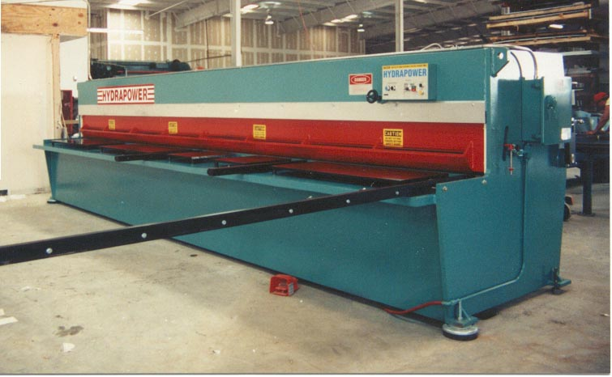

Our group consists of NCI, DBCI, MBCI, MIDWEST METALLIC plus some other companies in the metal building components industry. We have bought HYDRAPOWER brand since 1993. We now have 2 - 20’ X 3/16’ SHEARS, 2 - 20’ X 100 TON CNC PRESS BRAKES, 1 - 30’ X250 TON, and a 14’ X 250 TON STRAIGHT SIDE PRESS.
MIKE NESBITT
NCI
HOUSTON, TX

